Software Life Cycle

Software is like a human in that it has a life cycle. Software in a system is conceptualized first. It becomes obsolescent at the end. The period in between is called the software life cycle.

Why use a life cycle model?

Life cycle model breaks down the development process into phases or stages. This is because software development is complex. Breaking down the development process makes it easier to manage. Each phase can be performed in various ways.

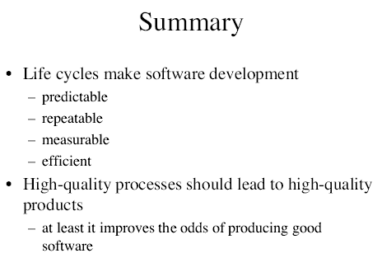
•Software is developed using a life cycle model.

Waterfall Model

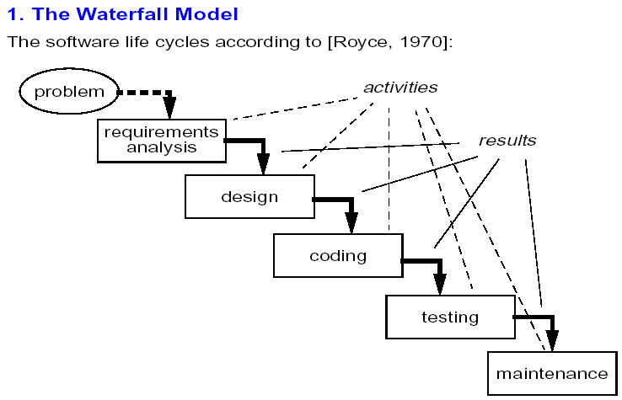
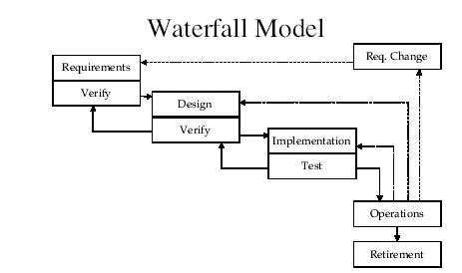

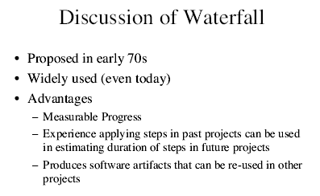
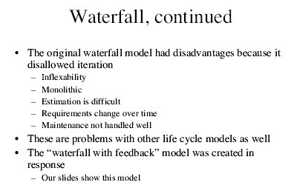

The Prototyping Model
Prototyping is another method that can be used to improve the user involvement in system development. The fundamental idea of prototyping is to build a small scale system that can then be used to gather more detail information or examine the abilities of the developing system. The system or the model is called a prototype. A prototype usually does not have all the functions that a completed system will have. It does not have to have full functionality nor the completion of the functions it has. A prototype is mainly used to present how a system will work. That means the processes and the data flow. As long as a prototype can show the users how the system will be like, acting or working, the prototype is a successful one.
The Prototyping model is often used when customers or users are unable to quantify or describe their requirements accurately for the software system. This is an iterative model with each successive phase becoming more detailed and strictly documented than the first.
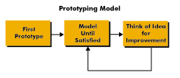

Evolutionary Prototyping
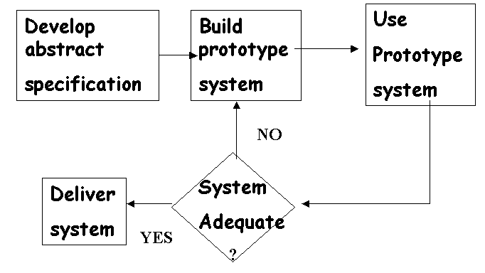
Evolutionary Prototyping is an approach to system development where an initial prototype is produced and refined through a number of stages to the final system. Evolutionary prototyping aims to deliver a working system to end-users. Because the prototype is evolving to be the final system, the quality is critical. Evolutionary prototypes are built in a quality manner, are given to the customer for feedback, and are modified once the desired information is learned to more closely approximate the needs to the users. This process is repeated until the product converges to the desired product.
Evolutionary prototypes should be built when the critical functions are well under stood but many other features are poorly understood. When constructing an evolutionary prototype, build the features that are best understood. Your hope is that, by experiencing these features, users will be able to better determine additional needs.
Advantages:
- When the final version of the prototype is completed, the system is implemented.
- While documenting each version of the prototypes, the system's documentation is processing.
- The versions of the prototype can be used as the training facility and maintenance.

Disadvantages:
- Using this prototyping approach could be extremely time-consuming for the quality must be controlled at every point.
- Heavy load of user participation will decrease the organization's productivity.
- The final system can be larger than the expectation due to the possibility of frequent modification made by the users since the users know more and more about how the system is capable of during the involvement.

Throw-away Prototyping
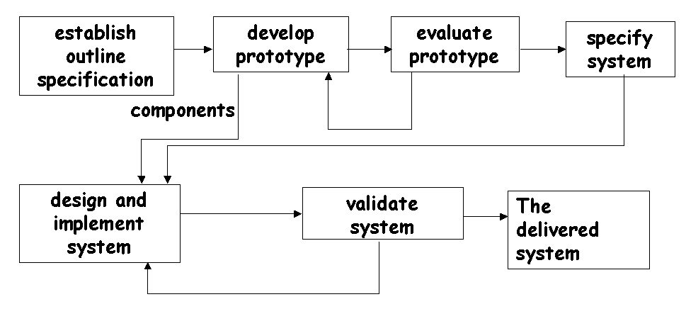

The idea of Throw-away Prototyping is to built a system in a quick and dirty manner, then give it to the customer for feedback, and are throw it away once the desired information is learned. This is a good solution when critical features are poorly understood. The desired information is captured in a requirement's specification for a full-scale product development. The purpose of throwaway prototyping is to find out unknown and determine if the understanding of the requirements is correct, so there is no reason to waste the work force as well as resources in making the model perfect. As long as the goal will be achieved, the prototyping can be built as quickly as possible.
Throwaway prototyping has been suggested to be a waste of effort. The simple argument is that to develop something that will be throwaway is a waste of resources. In fact, those who are for this point have failed to take a look at its deliverables. Although the final prototype is throwing away, the approach successfully establishes communication between the users and the system analysts, or let us say, the system itself. For it improves the user involvement, more features can be clarified and found. The errors can be adjusted before the system implementation starts. This reduces the risk of paying high cost in rebuilding the system.
Advantages:.
- The throwaway prototyping provides a fast system developing environment which remarkably reduces the system developing time.
- It can be used to examine and revamp existing system.
- Many prototypes can be built at the same time in order to fund out more features or examine more parts of the system.
Disadvantages:.
- Due to the quick development, documentation usually starts after the final system implemented. The documentation might lose some detail.
- A well-defined requirement is essential. Hence, the analysis phase will have to take longer time.
- It increases the system developing costs.
It is not suitable for developing a brand new system because it will need extra time to integrate the system and the integration could be difficult.

Incremental Model
Description
The incremental model performs the waterfall in overlapping sections attempting to compensate for the length of waterfall model projects by producing usable functionality earlier. This may involve a complete upfront set of requirements that are implemented in a series of small projects. As an alternative, a project using the incremental model may start with general objectives. Then some portion of these objectives is defined as requirements and is implemented, followed by the next portion of the objectives until all objectives are implemented. But, use of general objectives rather than complete requirements can be uncomfortable for management. Because some modules will be completed long before others, well-defined interfaces are required. Also, formal reviews and audits are more difficult to implement on increments than on a complete system. Finally, there can be a tendency to push difficult problems to the future to demonstrate early success to management.
Iterative development allows the developer to cycle through the different development stages.
It is essentially the waterfall model with backtracking.
However backtracking should not be used irresponsibly.
It should be used as a technique available to the developer to deal with unexpected problems that may arise in later stages of development.

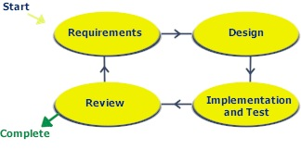
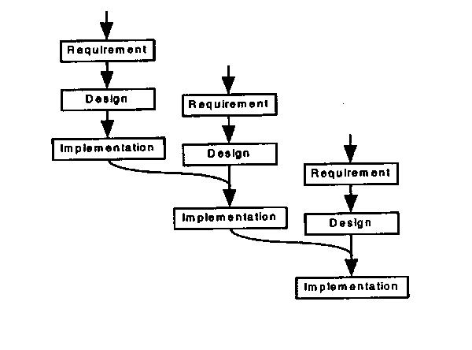
Where to Use the Incremental Model
If it is too risky to develop the whole system at once, then the incremental development should be considered.

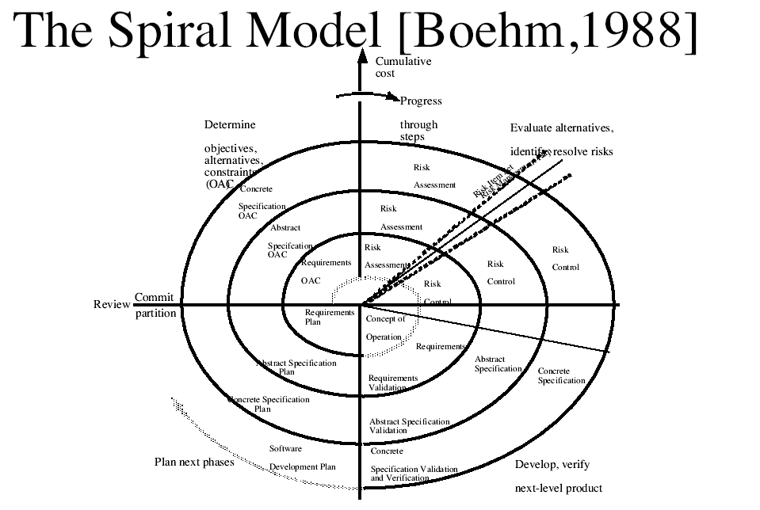
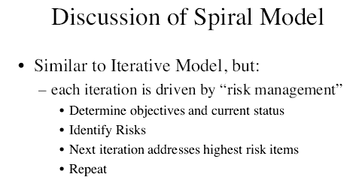

Software Reuse Model
Description
Software reuse is a process that employs software resources in more than one system. Reuse can occur within a system, across similar systems or in widely different systems. Reuse takes place when a developer from one system (client) uses a component provided by another system (donor).
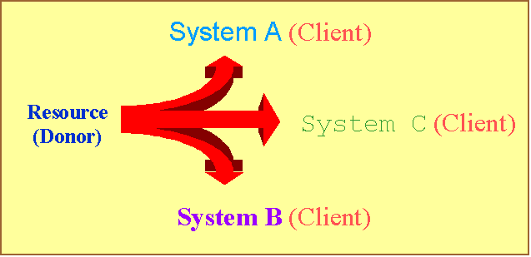
Reuse involves more than just code reuse. Reusable software components include requirements, designs and architectures, executable programs, code segments, documentation, test data and test plans, or software tools.

What is the difference between Systematic Reuse and Opportunistic Reuse?
Software reuse can be achieved to various degrees, in two different forms. The forms are either ad-hoc (opportunistic reuse) or planned (systematic reuse).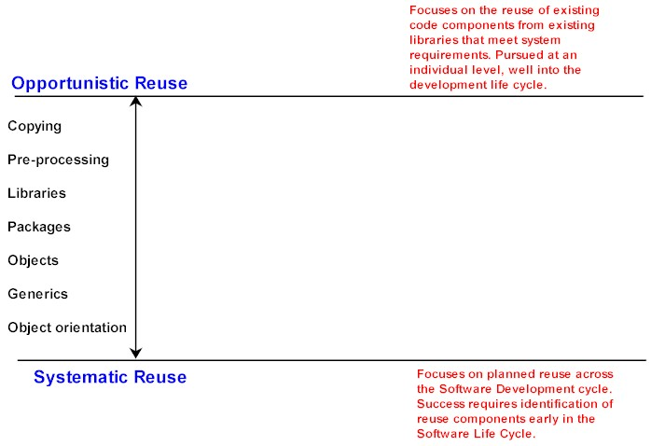
Systematic software reuse is the planned practice of using existing software components to develop new applications. Systematic software reuse is distinct from software salvaging, i.e., reusing software that was not designed for reuse. Systematic software reuse is planned, starting at the beginning of the software development life cycle; whereas, software salvaging is opportunistic, occurring intermittently during the development life cycle as a need arises. Also, systematic software reuse is different than carrying-over code; i.e., reusing code from one version of an application to another. Components of systematic software reuse are purposely designed for use in any application, whereas carry-over code is used because it works in a single type of application.
Systematic software reuse provides a basis for dramatic improvements in increased quality and reliability and in long-term decreased costs for software development and maintenance. It is essential to identify the life-cycle phases (Requirements, Architecture, and Detailed Design or Conception, Elaboration, and Construction) that will be supported by a reuse project. Historically almost all reuse efforts have been directed at code reuse, even though coding consumes only 10-15% of the time and effort on a software development project. The DoD emphasizes a broader approach, advocating the reuse of all software work products, i.e., requirements, architectures, detailed designs, and user documentation.

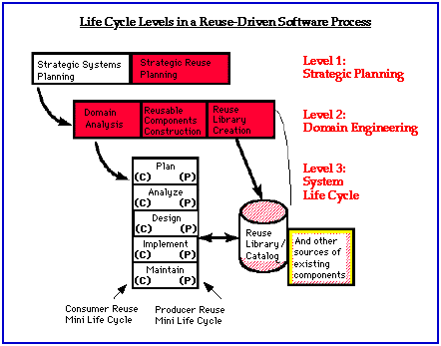

Why Reuse?
There is virtually no software project in which reuse should not be practiced. Software Reuse is the process of creating software systems from predefined software components. Software reuse has two sides: (1) the systematic development of reusable components and (2) the systematic reuse of these components as building blocks to create new systems. A reusable component may be code, but the bigger benefits of reuse come from a broader and higher-level view of what can be reused. Software specifications, designs, tests cases, data, prototypes, plans, documentation, frameworks, and templates are all candidates for reuse.
Reuse can cut software development time and costs. The major reasons for practicing reuse are to:
  - Increase software productivity
  - Shorten software development time
  - Improve software system interoperability
  - Develop software with fewer people
  - Move personnel more easily from project to project
  - Reduce software development and maintenance costs
  - Produce more standardized software
  - Produce better quality software
  - Provide a powerful competitive advantage
Reuse makes sense because the similarity found across software systems is enormous and undeniable. When we compare software systems, we usually find 60-to-70 % commonality from one software application to another. ¹ This includes code, design, functional and architectural similarities. At all levels of development from requirements specifications to code, there are components that by the nature of implementing tasks and representing information on a computer must appear over and over again in software applications. New technologies such as software automation, object-orientation and client-server do not change this; however, they do make it easier to take advantage of software similarities. Some software similarities can be predefined and built into software tools (such as reusable code patterns in generators); others can be created as reusable components which are stored in software reuse libraries.
The potential for reuse is enormous since the majority of each new application could be assembled from reusable components if the appropriate components could be predetermined and built prior to system development. Thus, it is a tremendous waste of resources to needlessly "re-invent-the-wheel" as is advocated in traditional develop-from-scratch software process models.

Reuse is more difficult to implement than other software technologies because it works best when applied above the single system level where there is more opportunity to reuse components and to get the pay-back from the investment in reuse. The broader the base on which to practice reuse the better. Ideally, reuse programs should extend across multiple systems, project teams and even organizational boundaries.

Reuse Successes
Tobshiba Software Factory reported 50% reuse over its product line in 1989 and increased productivity by 57%.
M. Cusumano, "The Software Factory: A Historical Interpretation," IEEE Software (March 1989)pp. 23-30.
- Hughes Aircraft Company Command and Control Systems Division created a Command Air Defense Ground Environment and reported a 37% savings on projected development costs for building two systems in this environment based on reuse.
Benjin, 1991, cited in Reuse Adoption Guidebook, SPC-92-051-CMC, Version 02.00.05,( November 1993), Software Productivity Consortium, Herndon, VA.
- CelciusTech Systems AB in Sweden developed its embedded shipboard command, control and communication application not separately but as a family of systems. They obtained up to 70 % reuse, doubled productivity, increased their competitiveness and saved $20 million.
Ted Davis, "Adopting a Policy of Reuse," IEEE Spectrum (June 1994) pp44-48.
- US Naval Surface Warfare Center, Virginia Beach, VA built a common architecture for a a family of combat direction systems. On fourteen ship system upgrades, the center achieved a level of reuse of 89-99%, a 3-fold reduction in defects, and an 8-to-10 fold increase in productivity.
Ted Davis, "Adopting a Policy of Reuse," IEEE Spectrum (June 1994) pp. 44-48.
- GTE Data Services reached a 50% reuse level in the third year of their reuse program which resulted in $12 million savings.
R. Prietro-Diaz, "A Domain Analysis Process Model," SPC-92032, Software Productivity Consortium, Herndon, VA.
- In a pilot project involving compiler and compiler-tool test suites at Motorola, an 85 percent reuse level and a 10:1 savings ratio have been demonstrated. The primary reusable components are design and documentation.
R. Joos, "Software Reuse at Motorola," IEEE Software (September 1994)pp. 42-47.

Automated software synthesis
This process is one level of abstraction higher and it relies on tools to transform requirements into operational code. Formal requirements are created and maintained using specification tools. These requirements are then transformed automatically to a certain intermediary form which is closer to a code in a programming language. This form is being automatically transformed to another forms closer and closer to the code. All those transformations are done without any participation of people.
formal requirements specification -> intermediary form -> … -> intermediary form -> code
The software created in such way is very reliable. If there were no mistakes in specifying the requirements, the code will be also free from mistakes and for this reason this model is interesting for projects where reliability is crucial. One of the institutions which are doing research on this field is NASA.
The disadvantages of this model are:
- The difficulty of specifying the requirements in a formal way. A formal specification language is just a high level programming language, so specification of the requirements is made by writing a code solving a certain problem. For complex systems it is still a difficult task.
- Low efficiency of the code generated this way
- There are no well developed universal languages of formal specification of requirements.
This is an active research area, and practical tools for this approach are yet to be developed. Although this model is still theoretical and it is not used, it shows an interesting point of view on software life cycle.

Strengths and Weaknesses of Models.
 | Waterfall | Incremental | Spiral
STRENGTHS
Allows for work force specialization | X | X | X
Orderliness appeals to management | X | X | X
Can be reported about | X | X | X
Facilitates allocation of resources | X | X | X
Early functionality |  | X | X
Does not require a complete set of requirements at the beginning |  | X | X
Resources can be held constant |  | X
Control costs and risk through prototyping |  |  | X
WEAKNESSES
Requires a complete set of requirements at the onset | X
Enforcement of non-implementation attitude hampers analyst/designer communications | X
Beginning with less defined general objectives may be uncomfortable for management |  | X | X
Requires clean interfaces between modules |  | X
Incompatibility with a formal review and audit procedure |  | X | X
Tendency for difficult problems to be pushed to the future so that the initial promise of the first increment is not met by subsequent products |  | X | X

Just a life cycle model is insufficient for development.

•We need:
–A broad philosophy
–A set of tools which support the philosophy.
–A language which supports the philosophy.

Software Development Paradigm

•A paradigm provides a general approach to work during each phase of the life cycle model.
•A paradigm is a broad philosophy.
•A paradigm is not a specific model.

Object Orientation

•Most recent paradigm.
•Treats a problem as a collection of objects.
•Becoming very popular now.
•More and more languages support this paradigm now.

Tools for Object Orientation

•UML
•Rambaugh (OMT)
•Coad-Yourdon
•Booch

Languages for Object O.

•C++
•Java
•Smalltalk
•Eiffel
•Object C
•Object Pascal

